ENGLISH 110: Visual Rhetoric and Document Design

San Jose State University

Prof. Mark Thompson

**Project #2: UI Design (100 pts.)**

For this assignment, you will be using Figma ([www.figma.com](http://www.figma.com)) to design the User Interface for two pages of an app:

1. Login/Sign-Up Screen
2. Main/Landing Page (Minimum 4 buttons/sections)

Remember the principles we have been talking about: CRAP, usability, “obviousness,” enclosure, color, conventions, etc.

1. As far as which app you are designing, you have three choices:

**Option 1: Redo This Bad One**

Using Figure 1 as a basic design, build out a nice-looking prototype that captures this functionality of these two screens in a much better way. Edit any text that stinks. Add color, photos, icons, etc. Make it look like a plant app! You have complete freedom to redesign and add things, just keep all of the elements present.

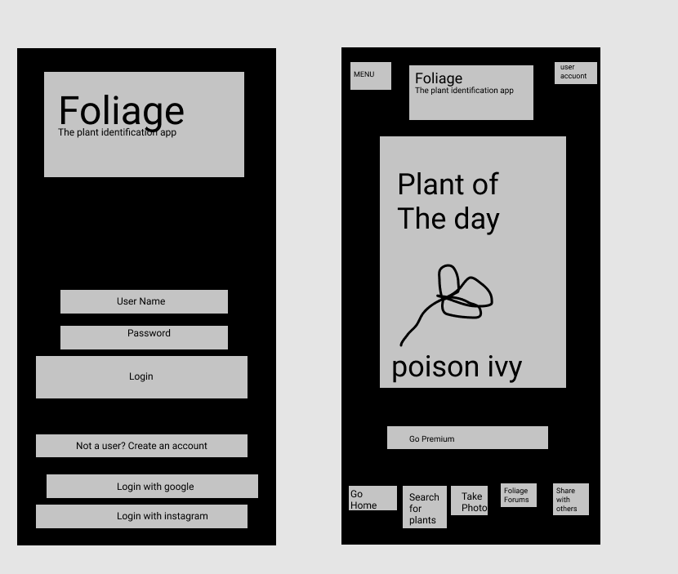  
 (Figure 1: Bad App, Bro!)

**Option 2: Redo an App on Your Phone**

If you choose this option, BE SURE TO INCLUDE screenshots to show the original version so I can see your new direction/improvements. You can copy and paste them into your Figma project.

**Option 3: Make Your Own App**

Go crazy! But within the confines of good UI and usability! If you choose this option, be sure to give a few sentences of explanation about what the app is/does. You can put this directly into the Figma project

1. Along with your app, you need to diagram out where each button goes.   
   Map your app hierarchy to the first level like we did in class. Do this directly in the Figma app using the pencil/pen tool and text boxes. See an example here:

<https://www.figma.com/file/9rCpBVTEYnOawV0Z0B77MG/Figma-Tutorial?node-id=0%3A1>

1. Turn in: A link to your Figma prototype.
2. Click **Share** in the upper-right corner.
3. Click **Copy link** and paste the link into the assignment text entry. (Figure 2)

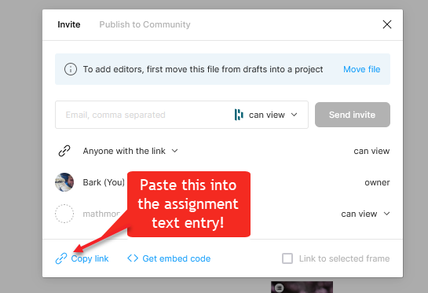

**(Figure 2: Figma share screen)**

*Please feel free to research other app UIs to draw inspiration!*

Due: Sunday, Oct, 1. 11:59 pm